**Databricks and Git integration**

To integrate Git hub with Databricks, we need to go to repo and connect or create a repo for our code.

You can create a folder in that folder we can import your repo.

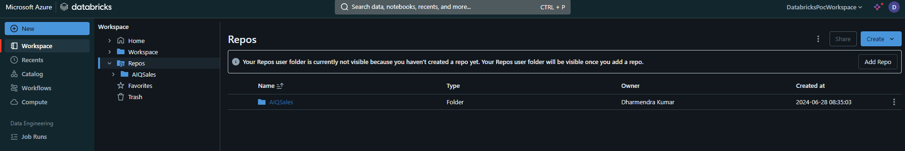

Note; choose your repo provider and authenticate your account with provided methods.

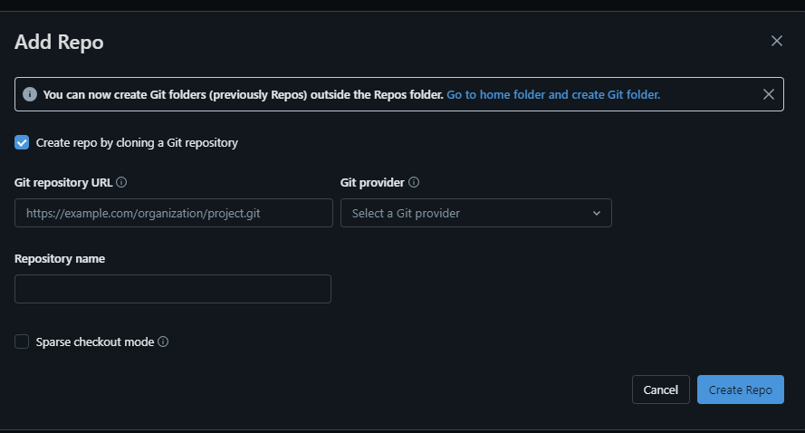

Once completed, you will see a result as below:

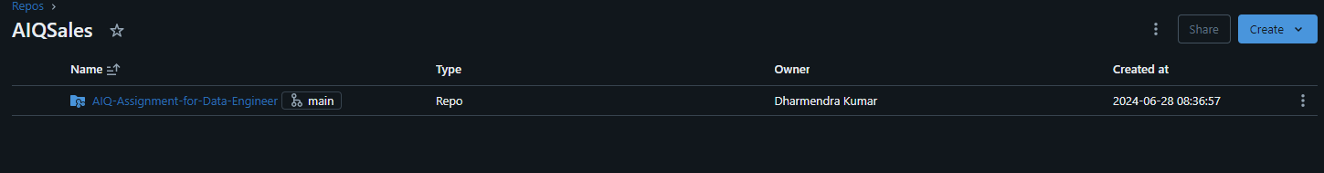

Now you need verify this by going to settings>linked_account

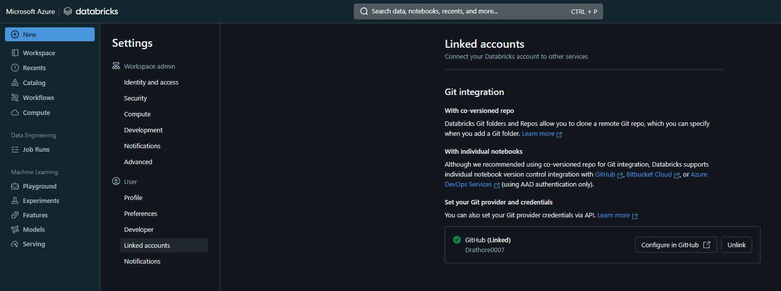

You should see Github integration there.

Once all the step are correct and verified.

You need to go to your GitHub account and install Databrick application.

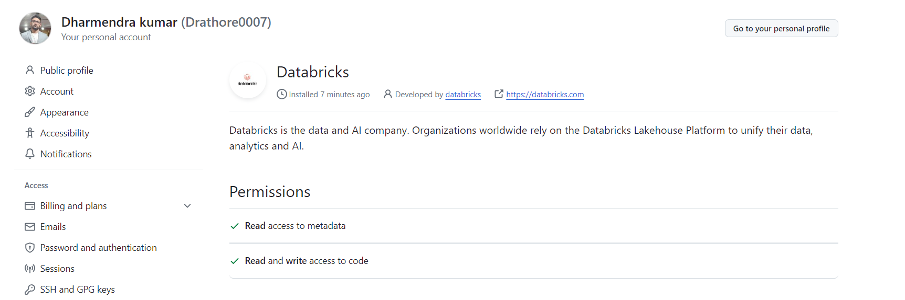

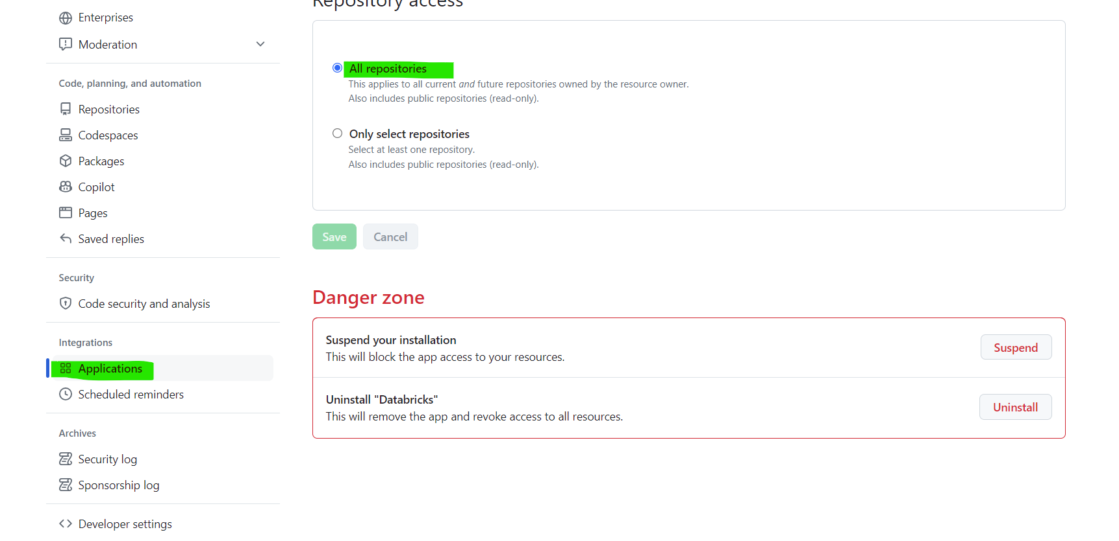

Once all the steps are performed correctly, you will be able to manage you repo from databrick.

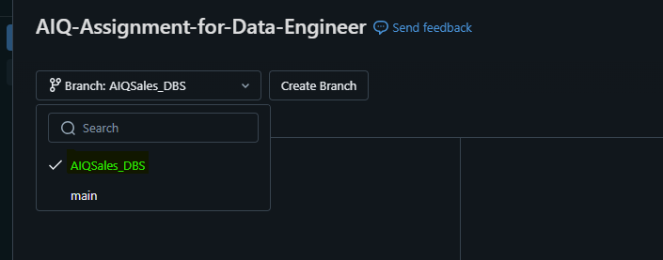

Now you can create your branch and start working on that branch to perform your changes.